METAL BUSSING UTILITY TRANSPORT CART
Model D‐2032‐MP

$312-End User Cost

Are you interested in keeping your operations free of harm from Covid-19? I have just the item for you. Contact Steve Farzetta from Nordon to hear more details @215-527-3101. Send leads to sfarzetta@nordoninc.com

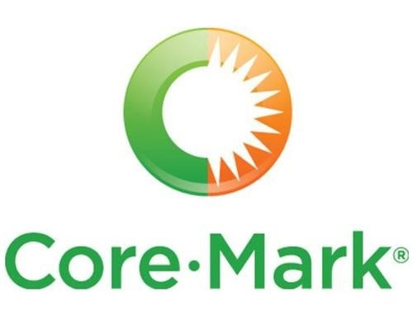

Sanitizing Cart, 20‐1/2" W x 34‐ 7/32" D x 40‐1/8" H, (1) top tray, (2) shelves, garbage & paper towels holders, push handle, aluminum construction, (4) swivel casters (2 with brakes), NSF

