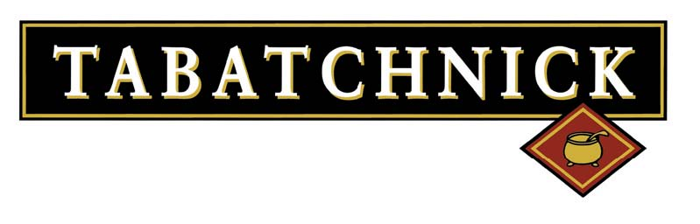
Home Heating Guide for Bowls
All Heating Instructions are for thawed product

Oatmeal Bowls:
- Microwave: Puncture top film on the bowl to vent bowl, heat in Microwave for 30-45 seconds, stir product, heat another 30 seconds if needed.
- Oven: Puncture top film on the bowl to vent bowl, place on baking pan and place in Oven at 350 degrees for 15 minutes, stir and check temperature, return to oven if additional heating is needed.
Macaroni & Cheese Bowls:
- Microwave: Puncture top film on the bowl to vent bowl, heat in Microwave for 30-45 seconds, stir product, heat another 30 seconds if needed.
- Oven: Puncture top film on the bowl to vent bowl, place on baking pan and place in Oven at 350 degrees for 15 minutes, stir and check temperature, return to oven if additional heating is needed.

Soup Singles Soup Bowls:
- Microwave: Puncture top film on the bowl to vent bowl, heat in Microwave for 30-45 seconds, stir product, heat another 30 seconds if needed.
- Oven: Puncture top film on the bowl to vent bowl, place on baking pan and place in Oven at 350 degrees for 15 minutes, stir and check temperature, return to oven if additional heating is needed.

Cheddar Cheese & Jalapeno Cheddar Sauce Cups:
- Microwave: Puncture top film on the cup to vent cup, heat in Microwave for 30 seconds, stir product.
- Stove Top: Using Sauce Pot with 1“ water, please Cheese Sauce Cups in shallow water but do not submerge the cups in water. Heat the pot slowly and remove Cheese Cups when heated

